Work report 1 sep 2021

Today I have trained the mask rcnn syncbn model till 68000 epoch

The evaluation results are as follows

1. Test Data

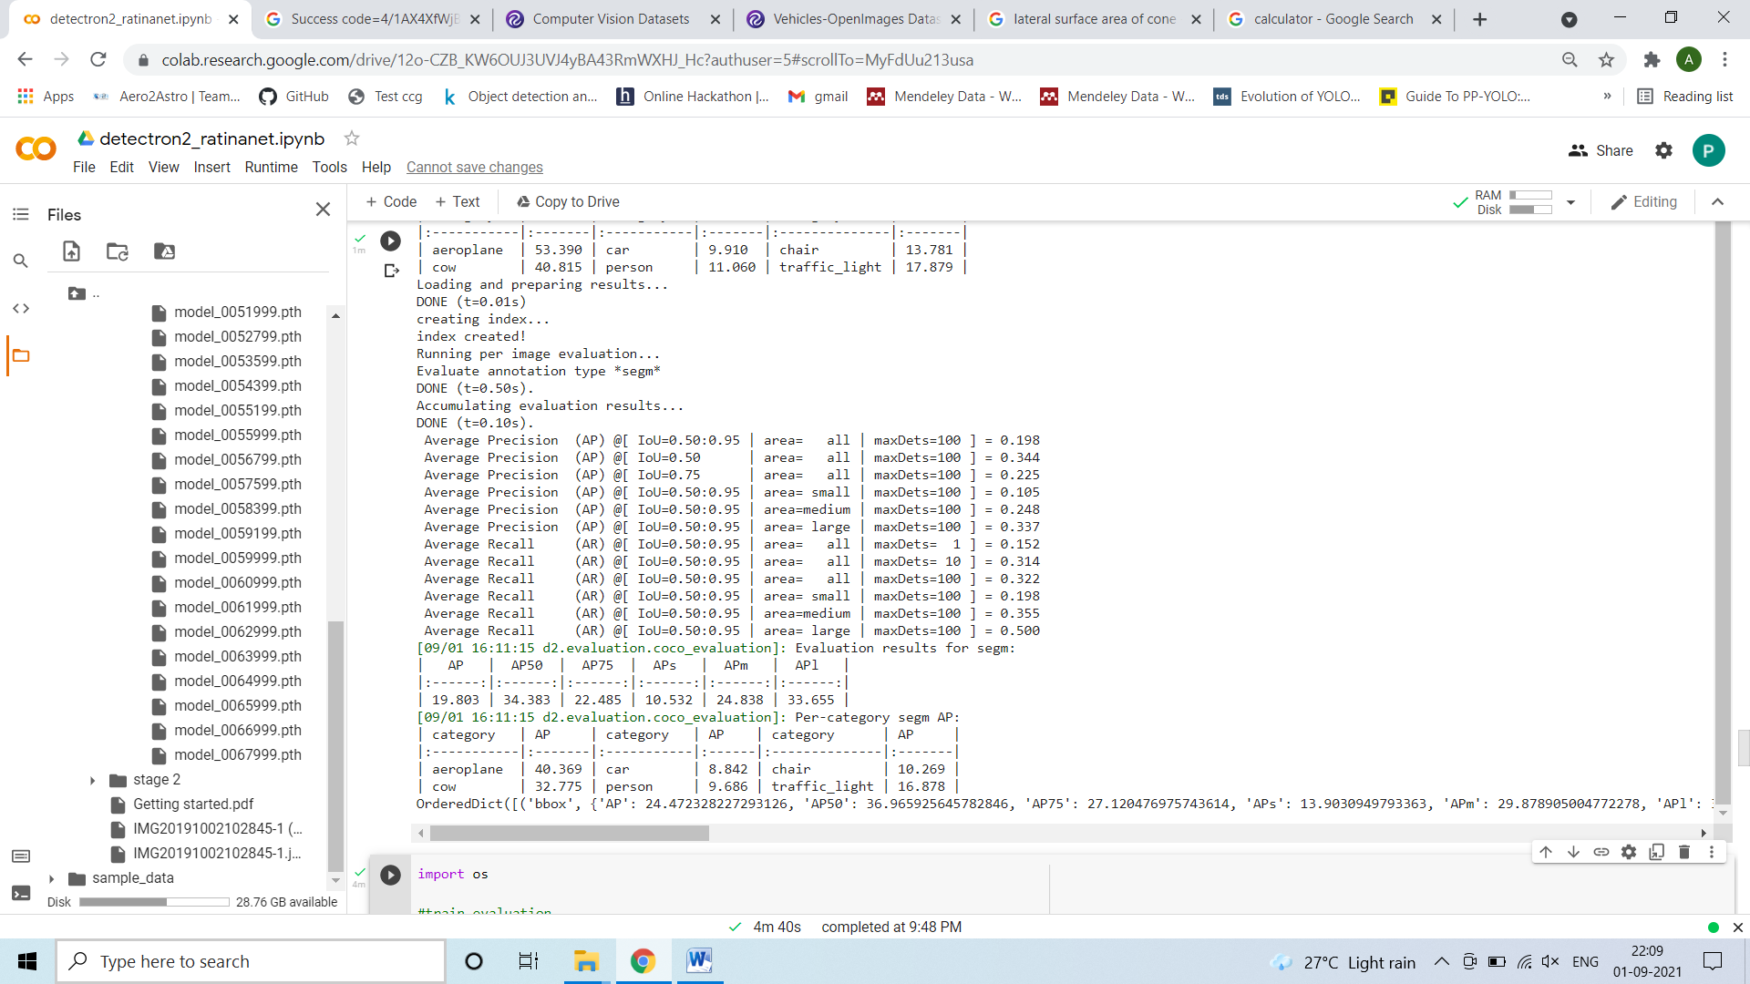

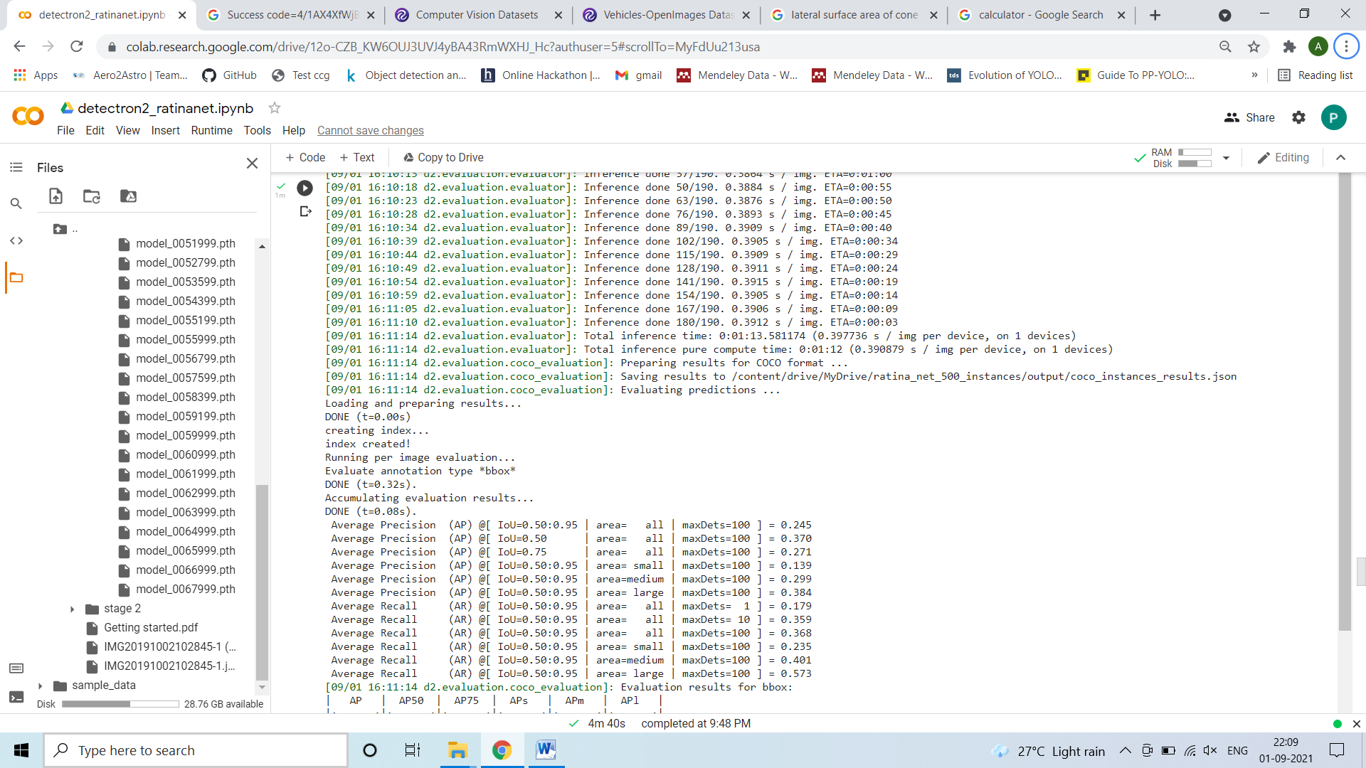

Train

